McEachern HS Athletics
2400 New Macland Road
Powder Springs, GA 30127
Principal: Regina Montgomery Athletic Director: Myra Camese
Head Track Coaches: Phil Hoskins & Cedric Sapp
Head Girls Lacrosse Coach: Pat Lynch Head Boys Lacrosse Coach: Ryan Baird

McEachern Track Complex
For GPS Directions, please enter
2395 Brand Road Powder Springs, Ga 30127

The following protocols are being put in place to help ensure student-athletes and essential personnel safety at home athletic events during the 2020-2021 school year. Please note that these protocols may change depending on guidelines issued from the CDC, Georgia Department of Public Health, Georgia High School Association and Cobb County School District.

Visiting School:
- All visiting schools and essential school personnel should be pre-screened prior to entering McEachern HS facilities.
- Our venue will be operating at 60% capacity (1,300 seats) – McEachern HS ticket sales are CASHLESS. Tickets can be purchased at: GoFan.co & select GHSA as the school
- Direct ticket link here: GHSA (Georgia) Events and Tickets by GoFan
- All tickets prices are $7
- Masks are required!
- Temperatures will be taken from all guests who enter the venue.
- COVID-19 questions will be asked of everyone.
- Social distancing guidelines will be enforced by school staff.
- Concessions will be available with pre-packaged items.
- Restrooms will be sanitized prior to each meet.
- Hand sanitizer will be provided at the venue.

MAP FOR McEACHERN SPORTS COMPLEX
For GPS enter, 2395 Brand Road Powder Springs, Ga 30127

Bus drop off & Guest Parking
Old Lost Mountain Road
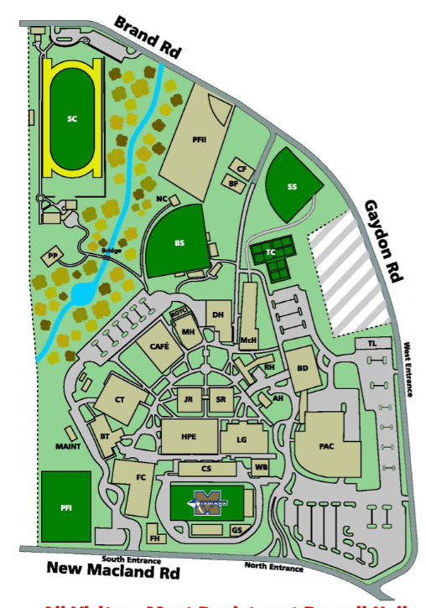
Bus Parking &
Additional Parking after 3:30
Additional Guest Parking AFTER 3:30 pm daily

